Where are we in the Universe?

Content Area: ESS1.A. The Universe and Its Stars
Specific Content Expectation:
1-ESS1-1: Use observations of the sun, moon, and stars to describe patterns that can be predicted.
5-ESS1-1: Support an argument that differences in the apparent brightness of the sun compared to other stars is due to their relative distances from the Earth.

Name: Abigail Melnik

Grade Level: 4-6
Time Needed: 30 minutes

Safety Considerations: No potential safety concerns.

Source (s):
- http://www.starrynighteducation.com/downloads/LessonPlang2HighSchool.pdf
- https://www.teacherspayteachers.com/Product/Moon-Phases-Flipbook-211718
- http://montalbanoscience8.weebly.com/uploads/1/2/6/6/12660564/9375882_orig.jpg

Materials Needed Per Group:
- Large flashlight (whole class)
- Small flashlight (whole class)
- Markers or colored pencils (per student)
- Moon phases flipbook handout (per student)

Overview of Activity: Students will begin by looking at an Hertzsprung-Russell Diagram and compare the Sun’s brightness to that of other nearby stars. The whole class will participate in a flashlight experiment. Students will fill out the moon phases flipbook and answer questions.

5E Instructional Model:

Engage: Why does the Sun appear so bright to us even though there are stars much larger and much brighter?

Show students attached H-R diagram.

Explore:
1. Place the small flashlight on a desk or table near the front of the room.
2. Place the large flashlight on a desk or table near the back of the room.
3. Have the students gather at the front of the room so they can all see both flashlights easily.
4. Turn on both flashlights.
5. Darken the room.
6. Observe and compare the apparent brightness of the two flashlights.
7. Move the two flashlights back and forth until they both appear to have the same brightness.

http://www.starrynighteducation.com/downloads/LessonPlang2HighSchool.pdf

Explain:
Why does the Sun appear so bright to us even though there are stars much bigger and much brighter?

Do you think life would still be possible on Earth if the Sun was much brighter and/or much bigger?

Elaborate/Extend:
Students will complete the moon phases flipbook using the attached handout. They will fill in each piece with the correct phase of the moon and will be able to see it change by flipping through their flipbook.

Evaluate:
Why does the moon have phases?

The same side of the moon is always facing Earth. True / False (circle one)

Seasonal Sunlight

Content Area: ESS1.B. Earth and the Solar System
Specific Content Expectation:
1-ESS1-2: Make observations at different times of year to relate the amount of daylight to the time of year.
5-ESS1-2: Represent data in graphical displays to reveal patterns of daily changes in length and direction of shadows, day and night, and the seasonal appearance of some stars in the night sky.

Name: Abigail Melnik

Grade Level: 3-6
Time Needed: 45 minutes and 15 minutes per shadow tracing

Safety Considerations: Monitor students outdoors on blacktop, especially if using a parking lot area.

Source (s):
- http://www.sundials.co.uk/leicester/fig02.gif
- http://www.ametsoc.org/amsedu/proj_atm/modules/Sun&Seasons.pdf
- http://www.science-fest.org/Seasons%20Module%20with%20Workbook.pdf
- http://www.cgtp.duke.edu/~plesser/outreach/kenan/Activity%204%20Shadow%20Tracing.doc

Materials Needed Per Group:
- Access to computers
- Worksheets
- Measuring tape or yardstick
- Sidewalk chalk
- Compass
- Access to blacktop

Overview of Activity: Students will begin by looking at a diagram of sunlight height in different seasons. Students will then use the “Why do we have Seasons?” module to answer the accompanying questions. To see how sunlight changes throughout the day, students will work in groups to see how their shadows changes throughout the day.

5E Instructional Model:

Engage: Examine the following diagram. Using the diagram as evidence, why does our day length increase and decrease throughout the year?

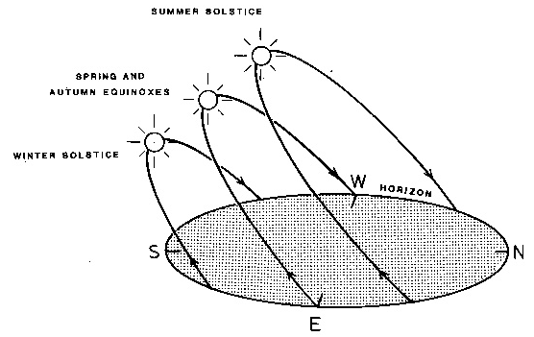

Explore:
Students will explore the “Why do we have Seasons?” module.
http://www.pbslearningmedia.org/resource/npls13.sci.ess.seasons/why-seasons/

Explain:
Why is it warmer in North America in June and colder in December?

Why is it winter in the northern hemisphere when it is summer in the southern hemisphere?

Elaborate/Extend:
Procedure:
Students will measure their shadows 3 times throughout the day (morning, noon, afternoon).
- Have students work in groups of 2-3.
- Have students face east and mark their spot with their name in chalk.
- A partner will trace their shadow with chalk (this will be repeated 3 times).
- Measure the shadow length and record the direction it faces (this will be repeated 3 times).

Shadow 1: Length_________ Direction__________

Shadow 2: Length_________ Direction__________

Shadow 3: Length_________ Direction__________

Does the Sun’s position in the sky cause your shadow to face a certain direction and change length?

Why did your shadow change position throughout the day?

Evaluate: Students will complete the “Why do we have Seasons?” crossword by answering the questions on the worksheet.

Earth through the Ages

Content Area: ESS1.C. The History of Planet Earth
Specific Content Expectation:
4-ESS1-1: Identify evidence from patterns in rock formations and fossils in rock layers for changes in a landscape over time to support an explanation for changes in a landscape over time.
2-ESS1-1: Use information from several sources to provide evidence that Earth events can occur quickly or slowly.

Name: Abigail Melnik

Grade Level: 2-5
Time Needed: 60 minutes (1st day); 30 minutes (2nd day)

Safety Considerations: Monitor students during use of tools to unearth the fossils (on the 2nd day).

Source (s):
- http://www.earthsciweek.org/classroom-activities/discovering-fossils
- http://www.starmaterials.com/VideoGuide/BN/BNL/Fossils/total.pdf
- https://www.youtube.com/watch?v=4LjqN4mStz4

Materials Needed Per Group:
- 3-4 fossils per pair
- One small tub per pair
- Mud
- Leaves, sticks, small objects (shells, army men, dice, etc.)
- Toothpicks, paint brushes, spoons (2 each per pair)

Overview of Activity:
Students will begin by looking at several real fossils. We will then go outside (weather permitting) and create our fossil containers. Students will fill their tub with mud and place leaves and sticks and small objects in several layers. The tubs will be left in the sun to dry or over the weekend. When the tubs are dry the students will try to unearth their fossils, being careful not to destroy their fossils. Students will make observations and answer the questions provided. They will also watch the Bill Nye the Science Guy episode on fossils and fill out the viewing guide. The last activity will have the students reading a short article and filling in a crossword puzzle.

5E Instructional Model:

Engage: Have students work in pairs to look at 3-4 real fossils. They will fill in the chart below with a picture and label for each.

Fossil Type | Drawing

Explore:

Procedure:
1. Fill tub with about ¼ inch of mud at a time (do this 4 times).
2. Place leaves, sticks, and/or small objects in each layer.
3. Place tub in sun to dry.
4. After tub is dry, take your tools and chip away at the layers to try to find the objects, imprints,
etc.

Explain:

1. Did the type of fossil you got depend on the item that was in the mud? What types did you
find?

2. If you found the fossil of a shell in a forest, what would that tell you about what the
environment was like in the past?

We will watch the Bill Nye the Science Guy episode on fossils. Students will fill out the attached viewing guide during the video.

Elaborate/Extend:
Students will read the “How Fossils are Made” article and will fill in the crossword puzzle.

Evaluate:
The teacher would ask several questions to check for understanding.
- What is a fossil?
- How are fossils created?
- How can we learn about the Earth’s history from fossils?

Whether it’s Weathering or Erosion

Content Area: ESS2.A. Earth’s Materials and Systems
Specific Content Expectation:
5-ESS2-1: Develop a model using an example to describe ways the geosphere, biosphere, hydrosphere, and/or atmosphere interact.
4-ESS2-1: Make observations and/or measurements to provide evidence of the effects of weathering or the rate of erosion by water, ice, wind, or vegetation.
2-ESS2-1: Compare multiple solutions designed to slow or prevent wind or water from changing the shape of the land.

Name: Abigail Melnik

Grade Level: 4-6
Time Needed: 60 minutes

Safety Considerations: Students will need to be monitored with the stream table to make sure flooding in the classroom doesn’t occur. No other safety concerns.

Source (s):
- https://www.youtube.com/watch?v=R-Iak3Wvh9c
- https://www.teachengineering.org/

Materials Needed Per Group:
- Projector and internet access (to watch video)
- Stream table (students will work in small groups and take turns)
- Small tub with sand
- One straw (per student)

Overview of Activity: Students will begin by watching the weathering and erosion video. Students will then work in small groups to use the stream table to explore erosion by water. They will then simulate wind erosion.

5E Instructional Model:
Engage: Watch the video “Weathering and Erosion.” https://www.youtube.com/watch?v=R-Iak3Wvh9c
Check for understanding:
What is weathering?
What is erosion?
Explore: Students will use the attached stream table worksheet.
Procedure:
- Set up the stream table with several rocks to change the flow of the water and channels, etc.
- Turn on the stream table.
- Make observations on the stream table worksheet.
- Turn off the stream table when a clear water pathway has been formed.

Explain:
How does erosion affect the environment?

What is the difference between weathering and erosion?

Elaborate/Extend:
Procedure:
- Take rectangular tub and fill with approximately 1 inch of sand.
- Blow on sand with straws to simulate wind.

How does wind change the environment?

Do you think the wind would be more or less effective in environments with a lot of trees? Why?

Evaluate:
How does water change the landscape?

How does wind change the landscape?

How does the landscape effect how it is eroded or weathered?

The Dynamic Earth

Content Area: ESS2.B. Plate Tectonics and Large-Scale System Interactions
Specific Content Expectation:
4-ESS2-2: Analyze and interpret data from maps to describe patterns of Earth’s features.
2-ESS2-2: Develop a model to represent the shapes and kinds of land and bodies of water in an area.

Name: Abigail Melnik

Grade Level: 3-5
Time Needed: 60 minutes

Safety Considerations: Be mindful of any food allergies or restrictions in your classroom and plan alternatives accordingly.

Source (s):
- http://evavarga.net/2014/09/18/modeling-plate-tectonics/
- http://ds.iris.edu/seismon/eventlist/index.phtml
- http://www.knowitall.org/nasa/pdf/scifiles/redlight_full.pdf#page=65

Materials Needed Per Student:
- Paper plate
- Two graham crackers
- Frosting
- One rice crispy treat
- Small cup of water

Overview of Activity: Students will fill out a worksheet on the layers of the Earth. In the Explore activity students will be using graham crackers to model plate boundaries and answering discussion questions. Then they will plot Earthquakes on a map and answer questions.

5E Instructional Model:

Engage: Students will complete the attached “Layers of the Earth” worksheet.

Explore/Explain: (Modeling Plate Boundaries)
Procedure:
- Split one graham cracker in half.
- Place a dollop of frosting on one side of each graham cracker.
- Place graham crackers next to one another on the plate.
- Slowly pull the graham crackers apart.

What type of plate boundary does this represent?

What type of feature is created from this type of plate movement?

Procedure:
- Take away one graham cracker from the plate.
- Take the rice cake and put a dollop of frosting on one side.
- Place the rice cake on the plate so it is almost touching the graham cracker.
- Slowly push the graham cracker and the rice cake toward one another until one rises over the other.

What type of plate boundary does this represent?

What is it called when one plate sinks below another?

Why does the oceanic plate sink below the continental plate?

Procedure:
- Take a new graham cracker and split it in half.
- Put a dollop of frosting on one side of each of the graham crackers.
- Dip one end of each graham cracker into the water until it is just soft.
- Immediately place the graham crackers side by side on the plate.
- Slide the graham crackers toward one another until a ridge is formed from the soft graham cracker.

What is this experiment modelling?

Where in the United States did this type of plate boundary occur?

Elaborate/Extend:
Students will use the world map to plot recent earthquakes from the data table. They will look at these points in comparison to plate boundaries.

Date | Latitude | Longitude | Magnitude | Depth (km)
12/6/15 | 36.45 | -98.69 | 4.3 | 2
12/5/15 | 43.89 | 85.24 | 5.0 | 10[‘;p
12/5/15 | -26.29 | -177.18 | 4.9 | 110
12/4/15 | -47.64 | 85.09 | 7.1 | 10
12/4/15 | -53.97 | -2.40 | 5.0 | 16
12/4/15 | 28.98 | 51.95 | 5.0 | 39
12/4/15 | -40.60 | 174.27 | 4.8 | 67
12/3/15 | 0.09 | 123.70 | 4.6 | 136
12/3/15 | -29.73 | -71.69 | 5.2 | 34

Do the earthquakes seem to correspond to plate boundaries?

Are there earthquakes that didn’t occur close to a plate boundary? What might be causing these anomalies?

Evaluate:
Students will fill out the tectonic plates activity sheet.

Teacher will ask questions aloud to check for understanding.
What are plate tectonics and what causes the plates to move?
What are the different layers of the Earth?

Water Keeps on Cycling

Content Area: ESS2.C. The Roles of Water in Earth’s Surface Processes
Specific Content Expectation:
5-ESS2-2: Describe and graph the amounts and percentages of water and fresh water in various reservoirs to provide evidence about the distribution of water on Earth.
2-ESS2-3: Obtain information to identify where water is found on Earth and that it can be solid or liquid.

Name: Abigail Melnik

Grade Level: 3-6
Time Needed: 45 minutes

Safety Considerations: No safety concerns.

Source (s):
- http://water.usgs.gov/edu/watercycle.html
- http://eisforexplore.blogspot.com/2012/04/water-cycle-wheel.html

Materials Needed Per Group:
- Worksheet packet
- Pop bottle set up (2L bottle, cotton ball, gravel/pebbles/sand)
- Bottle of dirty water (vegetable oil, dirt, water)
- Clear plastic cups
- Brass fastener (per student)
- Colored pencils
- Scissors

Overview of Activity: Students will begin activity by looking at the bar graph of the distribution of the Earth’s water and will answer questions. Then students will do an activity that shows how the Earth naturally filters our ground water. Lastly, students will create a water cycle wheel that they can use as a refresher and to study the parts of the water cycle.

5E Instructional Model:

Engage:
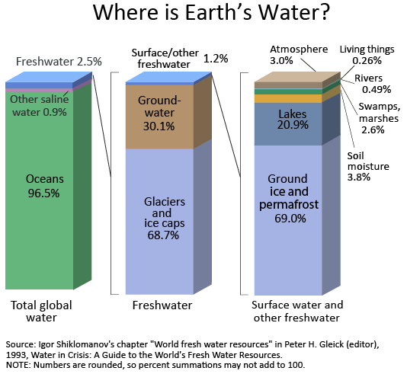
According to the above diagram, where is the majority of Earth’s water?

Using this diagram and your prior knowledge, why do you think it is important to keep our water clean?

Explore: Students will be exploring how the Earth naturally filters the ground water, so we can have clean drinking water.

Procedure:
- Stuff a wad of cotton in the top of your 2 L bottle and turn it upside down so it is resting in the clear plastic cup.
- Layer your bottle with the remaining materials. Each layer should be about 2 inches and should be in this order: pebbles, gravel, sand.
- Pour some of the dirty water into the filtering system and see what happens.

Explain:
- Explain how the water looked different after passing through the ground water filtering system.

- Why does this work to filter the water?

- What part of the water cycle does this activity represent?

Elaborate/Extend:
Students will create a “My Water Cycle” wheel using the attached worksheet. They can color the wheel and cut it out to create their own water cycle study wheel.

Evaluate:
- What are the four parts of the water cycle?

- Why is it important to conserve water?

- Why are scientists worried about the polar ice caps melting?

A Climatic Experience

Content Area: ESS2.D. Weather and Climate
Specific Content Expectation:
3-ESS2-1: Represent data in tables and graphical displays to describe typical weather conditions expected during a particular season.
3-ESS2-2: Obtain and combine information to describe climates in different regions of the world.
K-ESS2-1: Use and share observations of local weather conditions to describe patterns over time.

Name: Abigail Melnik

Grade Level: 2-5
Time Needed: 45 minutes

Safety Considerations: No potential safety concerns.

Source (s):
- http://www.education.com/worksheet/article/types-of-clouds/
- https://www.youtube.com/watch?v=ZouWWVyz9v8
- http://oceanservice.noaa.gov/education/pd/oceans_weather_climate/media/climate_zones.swf
- http://www.esrl.noaa.gov/
- http://www.layers-of-learning.com/climate/

Materials Needed Per Group:
- Worksheets
- Access to a computer & projector
- Access to computer lab
- Colored pencils

Overview of Activity: Students will begin the lesson with discussion questions and by filling out the “Label the Clouds” worksheet. We will then watch the “Intro to Clouds” video as a class. Students will use the interactive climate zones site and then fill out the climate zones on their map and answer questions. Students will fill out the global winds sheet and answer the questions as an extension activity.

5E Instructional Model:
Engage: Have you ever looked up at the sky at the clouds? I am sure you all have. All of those types of clouds have names.
Students will fill out the “Label the Clouds” worksheet.

Certain types of clouds are also the ones that have precipitation, or what we think of as weather. This is one of the this that makes up the climate. What other factors create the climate?
Watch the “Intro to Climate” video. https://www.youtube.com/watch?v=ZouWWVyz9v8

Explore:
Procedure:
- Students will explore climate zones using the online interactive site put out by NOAA. http://oceanservice.noaa.gov/education/pd/oceans_weather_climate/media/climate_zones.swf
- Students will color in the climate zones on the attached map.

Explain:
- Pick one of the three climate types. What might it be like to live there? (Think of clothes, activities, etc.)

- Identify a country in each of the three climate zones.

- How are these climate zones related to latitude?

Elaborate/Extend:
Have students complete the attached “Global Winds” worksheet.

Evaluate:
- What is climate?

- What factors influence climate?

- How are weather and climate related?

- How are the climate zones and global winds related?

Making Changes

Content Area: ESS2.E. Biogeology
Specific Content Expectation:
K-ESS2-2: Construct an argument supported by evidence for how plants and animals (including humans) can change the environment to meet their needs.
4-ESS2-1: Make observations and/or measurements to provide evidence of the effects of weathering or the rate of erosion by water, ice, wind, or vegetation.

Name: Abigail Melnik

Grade Level: K-2
Time Needed: 30-40 minutes

Safety Considerations: No safety concerns.

Source (s):
- http://static.panoramio.com/photos/large/5289806.jpg
- http://www.nrcs.usda.gov/Internet/FSE_MEDIA/stelprdb1049230.jpg
- https://upload.wikimedia.org/wikipedia/commons/thumb/f/f6/Beaver_dams,_Whitefish_Channel.JPG/1280px-Beaver_dams,_Whitefish_Channel.JPG
- http://4.bp.blogspot.com/-brb1mKx00ps/T5BgWGDc_wI/AAAAAAAAAJU/qbS-45HzIfY/s1600/bull+nasa+image.jpg
- http://www.global-greenhouse-warming.com/images/ForestCover.jpg?57ba6f

Materials Needed Per Group:
- Large copies of each of the included photographs
- Access to a computer with internet access and a projector

Overview of Activity: Begin by having a discussion about how humans change their environment. Students will then look at several photographs of different altered environments and will answer questions. They will then look at photos of deforestation of the planet. End with a class discussion.

5E Instructional Model:

Engage: Teacher will begin with an open discussion. Ask questions like:
- How do humans change the environment?
- Do you think animals also change the environment?
- What about plants?

Explore/Explain: Students will examine pictures and make observations about how plants and humans have changed the environment. You may want to look at the pictures as a class for kindergarten.
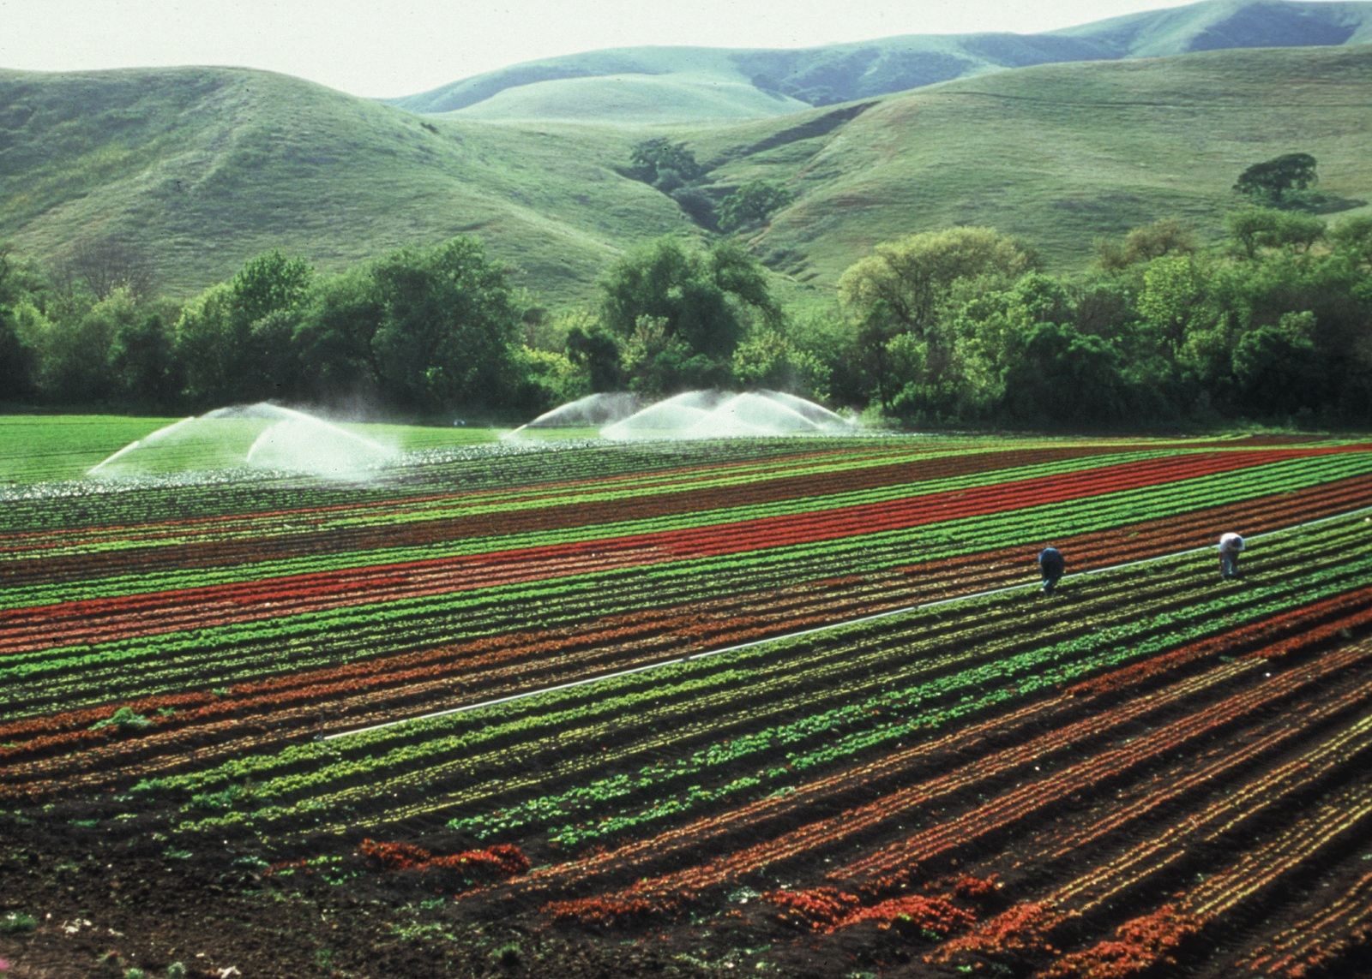

How do you think this landscape has been altered by humans?

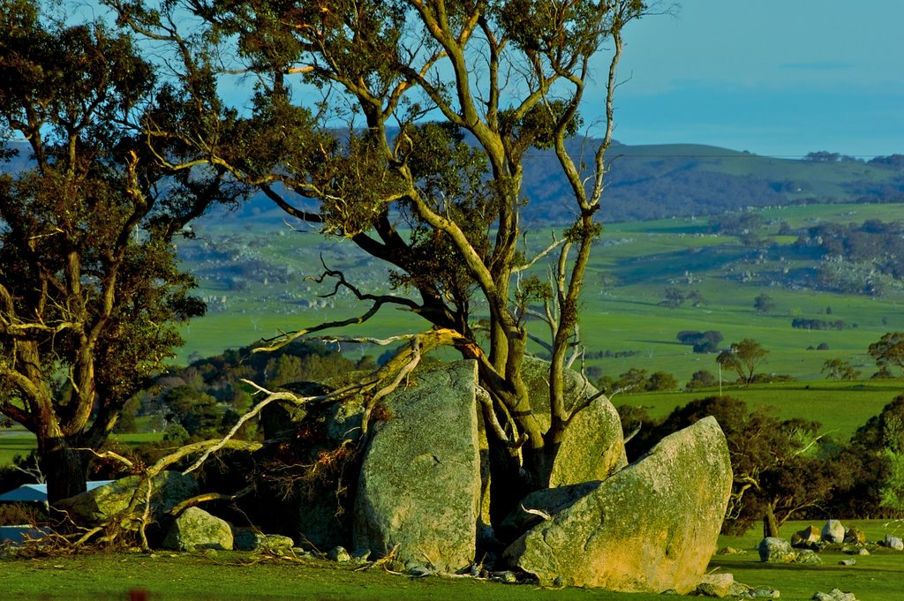

What happened to this rock? How did the tree alter the environment to meet its needs?

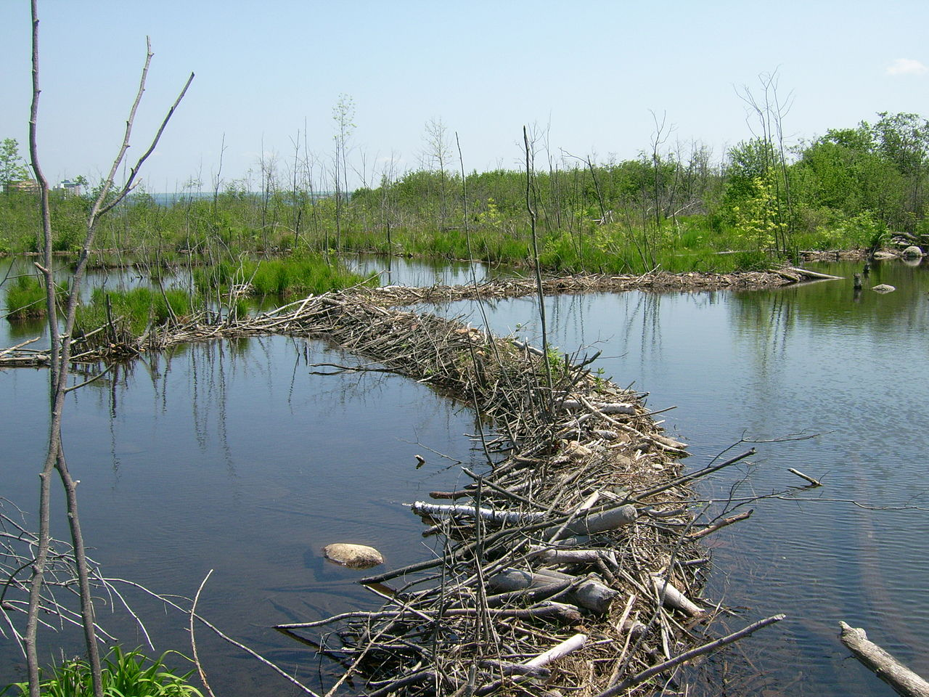

What is this a picture of? How did the beavers change their environment? How do you think this would change the river?
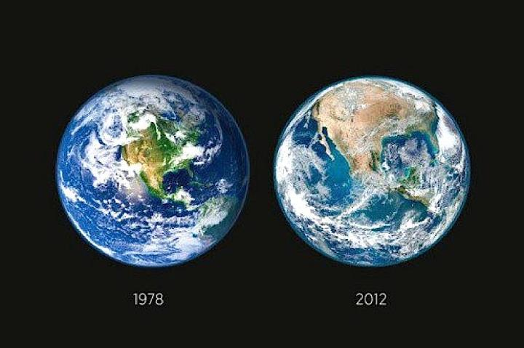
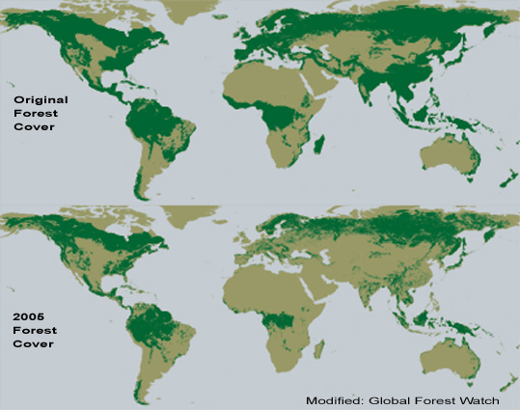
Elaborate/Extend: Students will look at images of the Earth and how much deforestation has happened. Make sure to use relatable language to the age group you are teaching. Tell them that it is a relatively short amount of time this happened in.

Evaluate:
Have a discussion as an entire class.

- What changes do you see?
- Do you think deforestation is a problem?
- What would happen if we had no more forests?
- What can we do to help prevent and/or reverse this problem?

Natural Resources and the Environment

Content Area: ESS3.A. Natural Resources
Specific Content Expectation:
4-ESS3-1: Obtain and combine information to describe that energy and fuels are derived from natural resources and their uses affect the environment.
K-ESS3-1: Use a model to represent the relationship between the needs of different plants and animals (including humans) and the places they live.

Name: Abigail Melnik

Grade Level: 5-8
Time Needed: 60 minutes

Safety Considerations: Make sure to go over safety precautions involving the use of needles.

Source (s):
- https://sites.google.com/a/beloit.edu/k-12_education/home/k-12

Materials Needed Per Group:
- Two large clear glass jar
- Bottle of water (1 quart)
- Food coloring
- Marbles (enough to fill one jar completely)

- Colored plastic or ceramic beads (black, red, white, blue, and yellow (same size and a few larger)
- Film canister (filled with the beads)
- Needle with thread. (Four thin enough to string beads and one slightly too large for all the beads, except for the larger yellow beads).
- Spool of thread
- Small prize for the winning team

- Several items made from petroleum

Overview of Activity: The teacher will begin the lesson with the “Where is Oil Found?” demonstration. Students will then participate in the natural resources “race.” Lastly, students will explore our use of petroleum products and how different our world would be without them.

5E Instructional Model:

Engage: Complete the “Where is Oil Found?” demonstration as a whole group.
Introduce the concept of oil reservoirs and how oil is found naturally in porous sedimentary rocks.

Procedure:
- Hold up the empty jar and ask, "Is this jar full?"

- Add marbles to fill the jar half full.

- Stop and ask, "Is this jar full?" Ask, "Can I put any more into it?"

- Fill the jar to the top with marbles.

- Ask, "Is the jar full, now?" The response is usually "yes." Ask, "Can I put anything more into the jar?" If the answer is "yes" follow-up with "What sort of thing?" The class may already have the concept of filling the pore spaces.

- Bring out the bottle of colored water and slowly pour it into the jar of marbles. Once the jar is filled to the top, stop and repeat, "Is the jar full?" The response should be "yes".

- Proceed with the analogy that the marbles are like the grains of sand in a sandstone and that crude oil is found within these pore spaces. This is a reservoir.

- Following the discussion, you could demonstrate that oil is lighter than water by dropping a few drops of cooking oil into a jar with colored water. Shake it up a little, and the oil droplets will rise to the surface.

Explore:
Procedure:
- Prior to class place beads into a 35mm film cannister: Black (coal) 50%, Blue (oil) 37%, White (natural gas) 10%, Red (uranium) 3%, Yellow (solar) a quantity exceeding coal (If possible, crush some of the yellow beads before putting them into the canisters).

- Before the class arrives, hold the cannister and heave the contents forcefully towards the ceiling so that they spread out over a wide area.

- Divide students into five teams (or companies). Assign each team a resource by color. Do not tell them what resources are represented by the colors.

- Give each team a needle with a foot of string already threaded and knotted. Give the solar company the larger needle on which the normal-sized beads cannot possibly fit, but that the large-holed beads will. DO NOT tell them that their needle is any different from the rest.

- Each team will have a total of two minutes to gather and thread as many of their colored resource as possible. Tell them that the winning team will receive a prize. Only beads that are threaded will be counted. (Note later how many teams spent too much time finding and not enough time converting the resource into a usable form of energy.) Stress that they must stop when the time is up.

- Two minute search.

- Have teams count how many beads are now strung. Record this on the board.

- Tell students that they will have one more chance. By now the yellow team will be crying about how life is unfair.

- Repeat steps 5-7. Make a mental note of any increased efficiency in technique or time use.

- Tell students that there will be one more final round in which to win.

- Four minutes search.

- Record the results of how many were gathered during round three and then total all three rounds and distribute the prizes. No doubt several groups will smell a rat by now.

Explain: You can complete these questions as a class.
- What resource did each color represent?

- Ask the class if any of them moved desks, books, rugs, etc. without putting them back. How does the current environment compare with the one before you began? Does the energy gained justify the damage?

- Were some resources harder to find than others? Is this a mirror of the real world?

- Now to our poor solar group. Abundance of a resource does not result in ease of gathering and especially utilization. Some solar is easily used (passive solar for heating represented by the large yellow beads). However, technological breakthroughs may be necessary to fully capitalize upon a particular source.

Elaborate/Extend: Students will discuss the uses of petroleum products.
Bring in several petroleum products. Be sure to bring in several items of different types so students can see how widespread their use is.

- Discuss pollution related to the use of petroleum. Guide the students to an understanding that the use of petroleum has environmental consequences. Are there things they can do in their own lives to prevent or decrease these consequences?

- Are their alternative products we could use that are made of renewable/sustainable resources? (i.e., bamboo products)

- How would the world be different if we didn’t have any more petroleum products?

- Are there petroleum products the students are willing to live without in order to prevent pollution? What ideas can the students suggest to deal with pollution problems related to the use of petroleum? Can we use petroleum more wisely?

Evaluate:
What is a petroleum reservoir? Are these easy to get to?

How can we help conserve energy in order to help avoid pollution?

Is solar energy worth expanding on even if it is harder to utilize?

Severe Weather and Natural Disasters

Content Area: ESS3.B. Natural Hazards
Specific Content Expectation:
3-ESS3-1: Make a claim about the merit of a design solution that reduces the impacts of weather-related hazard.
K.ESS3-2: Ask questions to obtain information about the purpose of weather forecasting to prepare for, and respond to severe weather.
4-ESS3-2: Generate and compare multiple solutions to reduce the impacts of natural Earth processes on humans.

Name: Abigail Melnik

Grade Level: 4-8
Time Needed: 60 minutes

Safety Considerations: Monitor students with water.

Source (s):
- https://www.youtube.com/watch?v=A1IxIKLV68E
- https://www.youtube.com/watch?v=dEjtxUhIjmc
- http://www-tc.pbs.org/wgbh/nova/education/activities/pdf/2307_flood.pdf
- http://www.ready.gov/floods
- https://www.floodsmart.gov/floodsmart/pages/flooding_flood_risks/defining_flood_risks.jsp

Materials Needed Per Group:
- Computer with internet access and a projector
- Aluminum baking pan
- Modeling clay
- Water
- Sponges
- Colored pencils
- Paper
- Access to a computer lab

Overview of Activity: The teacher will start with talking to students about flooding and how we can help prevent it. Students will watch the “When a levee breaks” video. Then students will complete the “When a levee breaks” activity. Lastly, they will explore the FEMA website.

5E Instructional Model:

Engage: Begin by asking student what they know about flooding and how we try to prevent it. You could discuss hurricanes and how they can cause massive flooding. Depending on the age of the students they may also remember hurricane Katrina. Then have the students watch the video “how levees fail, how we fix them.”
https://www.youtube.com/watch?v=A1IxIKLV68E

Explore: Students will simulate a levee break.
Show students the video “When the levee breaks.” https://www.youtube.com/watch?v=dEjtxUhIjmc

Procedure:
Students will complete attached “Overflowing the Banks” activity and questions.

Explain:
- What happened when the water reached flood level in your model?

- Why do we change our environment?

- How would you modify your model to better prevent flooding?

Elaborate/Extend:
Students will explore the website http://www.ready.gov/floods and answer the following questions. (This could be completed as homework).

What are some safety tips FEMA has for preparing for and dealing with floods?

What is the difference between a flood watch and a flood warning?

What are some characteristics of a high-risk flood area? (https://www.floodsmart.gov/floodsmart/pages/flooding_flood_risks/defining_flood_risks.jsp)

Evaluate:
Why do we try to forecast weather?

What are some of the ways we try to prevent natural disasters from occurring?

What’s our Responsibility to Earth?

Content Area: ESS3.C. Human Impacts on Earth Systems
Specific Content Expectation:
5-ESS3-1: Obtain and combine information about ways individual communities use science ideas to protect the Earth’s resources and environment.
K-ESS3-3: Communicate solutions that will reduce the impact of humans on the land, water, air, and/or other living things in the local environment.

Name: Abigail Melnik

Grade Level: 3-5
Time Needed: 45 minutes

Safety Considerations: No safety concerns.

Source (s):
- http://www.esrl.noaa.gov/
- https://www.durham.ca/
- http://www.smithsonianmag.com

Materials Needed Per Group:
- Two cut off plastic 2 L bottles - Two thermometers
- Masking tape - Plastic wrap
- Scissors - Colored pencils
- Graph paper - Dark soil
- Sunlamp - One rubber band

Overview of Activity: Start with an open discussion with students to get them thinking about climate change and the Greenhouse Effect. In their explore activity they will create a simulation of the atmosphere with both the Greenhouse Effect and without.

5E Instructional Model:

Engage: Start with a discussion with your students.
Who’s heard of the Greenhouse Effect?
How is this related to climate change and CO₂ emissions?
What can we do to help?

Explore:
Procedure:
- Tape a piece of cardboard over the thermometer.
- Add about 1 inch of soil to the bottom of each bottle.
- The thermometer should be taped to the inside of the bottle about 2 inches from the bottom.
- Record the starting temperature of the thermometer in each bottle.
- Place plastic wrap over one of the bottles and secure with a rubber band.
- Place both bottles under a sun lamp and turn it on.
- Record the temperature in each bottle every minute for 15 minutes.
- Create a graph with the data from your table.

Time | Uncovered Bottle (℃) | Covered Bottle (℃)
0
1
2
3
4
5
6
7
8
9
10
11
12
13
14
15

Explain:
- Which bottle ended up with the higher temperature?

- According to the graph you created, which bottle heated up faster?

- Why did that bottle heat up faster than the other?

- Which bottle is most similar to the Earth’s atmosphere?

We will then watch the video “Climate Change 101” narrated by Bill Nye.
http://www.smithsonianmag.com/videos/category/3play_1/climate-change-101-with-bill-nye-the-science/?no-ist

Elaborate/Extend:
Students will think about what they have learn about climate change and fill in the attached crossword puzzle by answering the questions (the clues).

Evaluate:
- What is the Greenhouse Effect?

- What is one of the main causes of climate change?

- How can we help to reduce our effect on the environment?

